『The 5th Jeollanamdo Kuksu Mountains
International Baduk Championship』
International Youth Baduk Festival

◆ Date: 2018. July 27(Fri) ~Aug 01(Wed)
◆ Schedule and Venue
Area | Place | Date | Content
Gangjin  County | Gangjin  Gymnasium | July 28(Sat) 10am - 29(Sun) | International Tournament
Youngam  County | Youngam  Gymnasium | July 28(Sat) 10am - 29(Sun) | International Friendly Match
Shinan  County | Shinan Lee Sedol Memorial Hall | July 30(Mon) 11am | International Team Tournament

◆ Qualification for participation: Less than or equal 18 years old
◆ Registration: download and fill out the Entry form from the kuksu mountain
Website (http://kuksumt.baduk.or.kr/) and register again
by 5pm 29.June
◆ Registration Fee (per person)
Youth | Accompanying Person | Team Leader
Free | 300,000 KRW(270 USD) | 300,000 KRW(270 USD)
Free meals and accommodation(5 nights)

- During the tournament period, all accommodation, transportation, meals and sightseeing fees will be covered by organizers. (Including the all accompanying people)
- The registration fee for the team leader will be waived if he/she brings more than 20 people.

◆ Event Information
- Depending on a player’s Go level, he/she will play 6 games with Korean participants (Gangjin County)
- A 6-game friendship match in which Korean and international players team up together Youngam County)
- Various events in all of the three tournaments
- Sightseeing and shopping opportunities through which you can feel attraction about Jeollanamdo Province
- Opportunities to meet pros who will be participating in the Korea-China Kuksu Mountains Team Competition and International Pair Go Tournament.
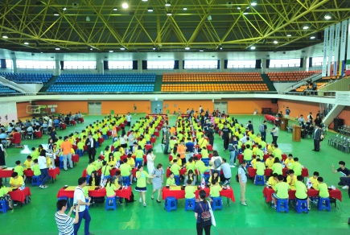
◇ Youngam Tournament
- A six-round 100:100 international team competition
- Three divisions depending on a player’s Go level
(33 Groups in total)
- Prizes for best performing players as well as various participants
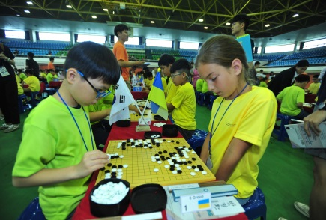
◇ Gangjin Tournament
- A six-round International Tournament divided into
three divisions (Dan/Group A/Group B, 64 players each)
- Prizes for best performing players
◇ Shinan Tournament
- A two-round team competition for best players
- 64 players will be chosen (32 players for the Korean team and another 32 players for the international team.) Depending on the outcome from the two games, the result will be determined.
- Various prizes for the winner and runner-up team

◇ Side Events(public game commentary, Signing Event, magic show, etc.)
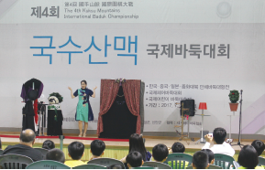
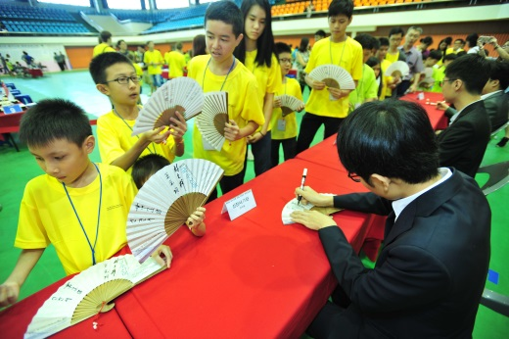
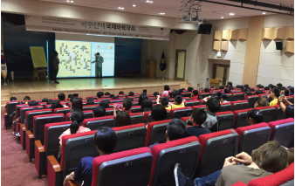

※ Various side events will be organized in each tournament separately.
◆ Awards
- Awards and material prizes will be given to best performing players
- Various material prizes (Go Board signed by famous pros, Go equipment, special local products, books, portable fan, stationery, etc.)
 | 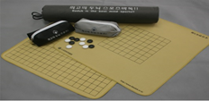 | 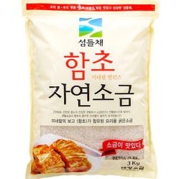 | 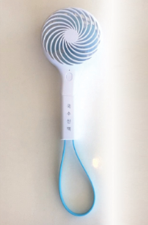

◆ Accommodation (2 star hotel)
- Wolchulsan Oncheon Tourist Hotel
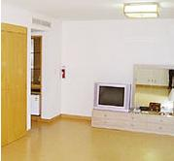
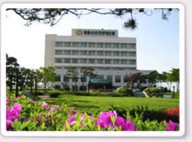
* Room types: one bed, two bed, no bed / spa is available

- Gangjin Dasan Training Center
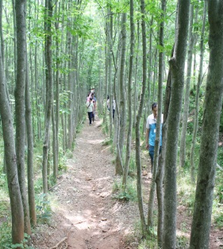
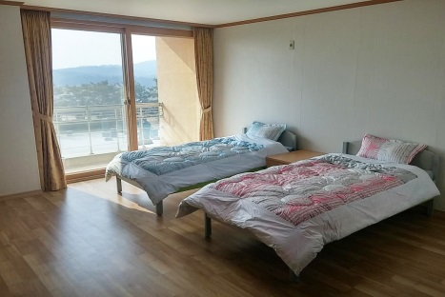
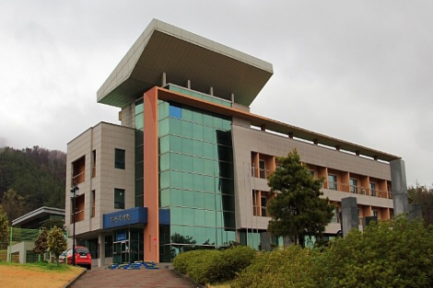
(33, Dasansuryunwongil, Mandeok-ri, Doam-myeon, Gangjin, Jeonnam)
* Room types: one bed, two bed, no bed
-Gangjin Baseball Park Resort
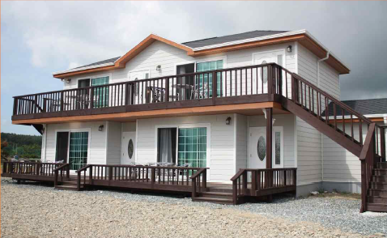
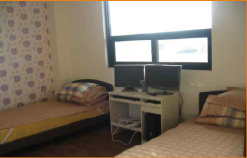
* Room Types: Guesthouse

◆ Sightseeing
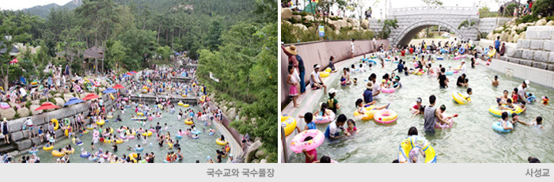
- Youngam Wolchulsan Kichan Land (Outdoor Pool)

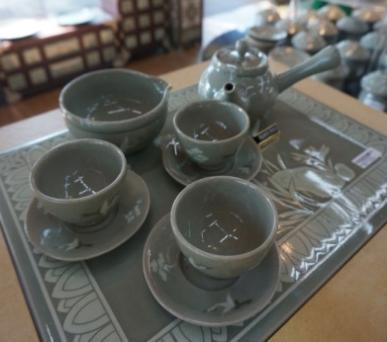
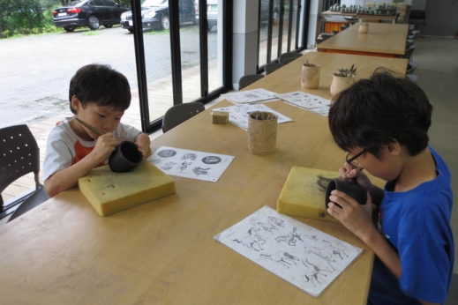
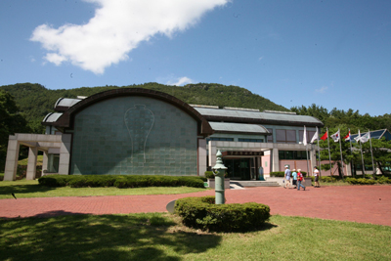
- Gangjin Celadon Museum (Museum Tour, Celadon making, Celadon shopping)

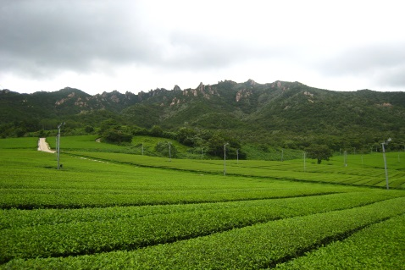
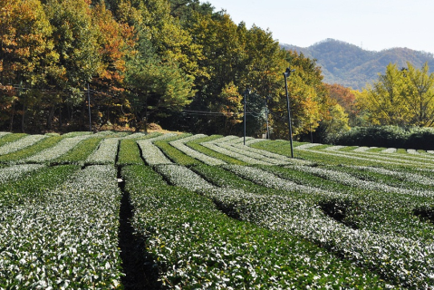
- Gangjin Greentea Farm

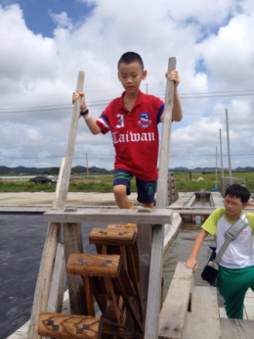
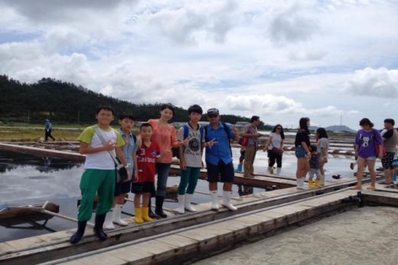
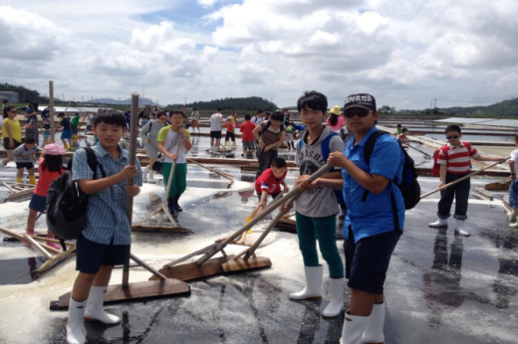
- Shinan Salt Evaporation Pond

- Shinan Heart Beach
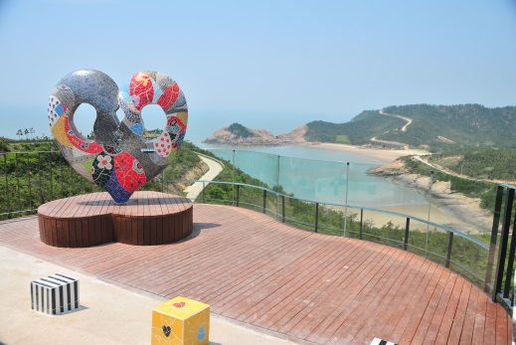

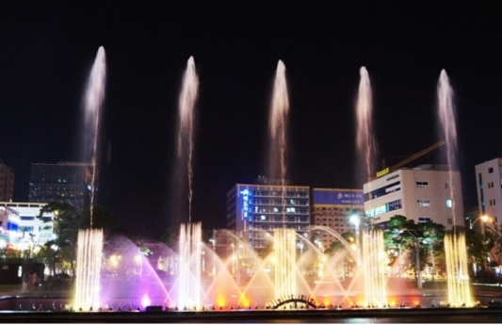
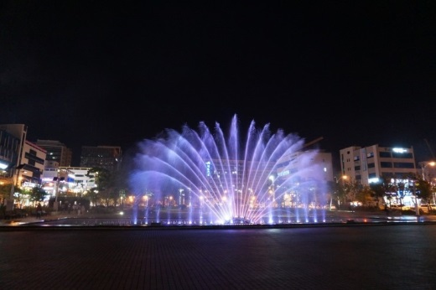
- The Dancing Music Fountain at Mokpo Peace Plaza
◆ Shopping
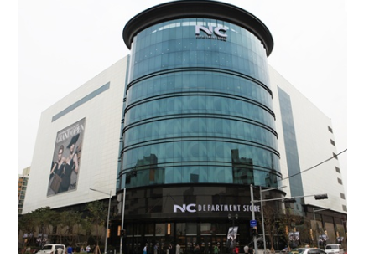
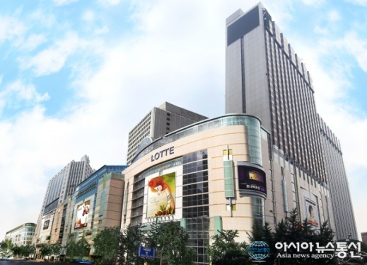
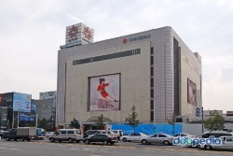
- Gwangju Area (Shinsegye, Lotte, NC Department Store, etc.)

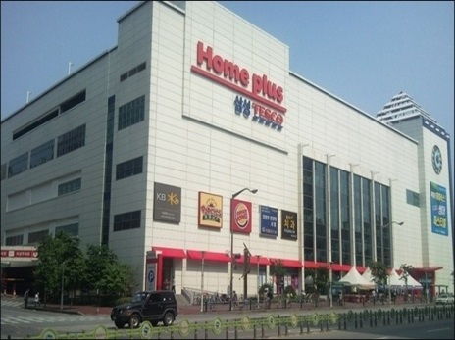
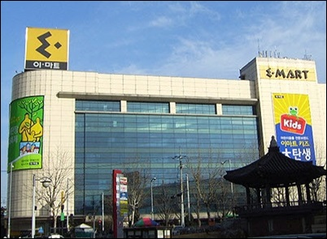
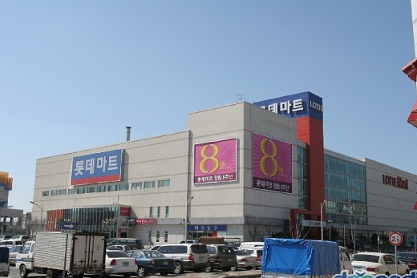
- Mokpo Area (Lotte Mart, Emart, Homeplus, etc.)

◆ Miscellaneous gifts will be given to all participants
◆ Contact: chhoi25@nate.com
◆ Host Organization: Korea Baduk Association(KBA)
◆ Organized by: Korea Baduk Association(KBA), Jeonnam Baduk Association
◆ Sponsored by: Jeonnam Province, Gangjin County, Youngam County, Shinan County

◆ Schedule
Time | 7/27(Fri) | 7/28(Sat) | 7/29(Sun) | 7/30(Mon) | 7/31(Tue) | 8/1(Wed)
08:00 | Arrival | Breakfast | Breakfast | Breakfast | Breakfast | Breakfast
09:00 |  | Move to tournament venue | Move to tournament venue | Move to tournament venue | Tour  and  Shopping – Jeonnam | Move to airport
10:00 |  | Youngam  /Gangjin  Tournament  1 Round | Youngam  /Gangjin  Tournament  4 Round | International Team Tournament  1 & 2 Round  (Tour program for non-participants)
11:00 |  | Youngam  /Gangjin  Tournament  2 Round | Youngam  /Gangjin  Tournament  5 Round
12:00 |  | Lunch | Lunch |  | Lunch | Departure
13:00 |  | Youngam  /Gangjin  Tournament  3 Round & side events | Youngam /Gangjin Tournament  6 Round  & side  events | Lunch | Tour  and  Shopping – Jeonnam
14:00 |  |  |  | Tour Program – Shinan County
15:00
16:00
17:00 | Move to Eve Party site  (Overseas Group)
18:00 | Eve Party  (Gangjin)
19:00 |  | Dinner | Dinner | Dinner | Dinner
20:00 | Move to Hotel/  Free time | Free time | Free time | Free time | Free time
* This schedule is subject to change.

